1. Not Null constraint -> If we will mark a column as not null,It will be mandatory for us to provide value. 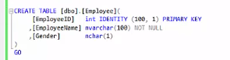
2. Default constraints:

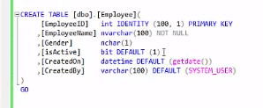

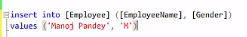I don’t need to specify the values for default in my insert statement.It’s not mandatory however we can give it if we wish to.

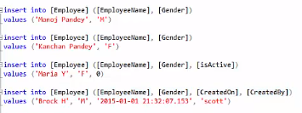

1. Check Constraint. It checks the value we are inserting in particular column falls in mentioned category.

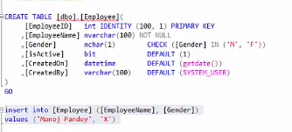

We can also provide name to our constraints by providing following syntax

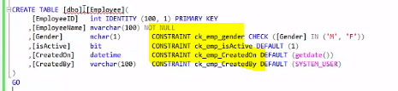

To add a constraint we can write



1. Primary key:

* Table can have only one primary key .

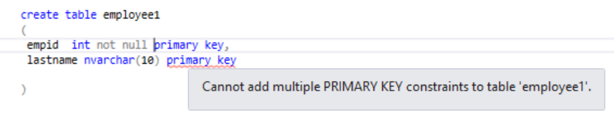

* We must add not null constraint to primary key
* By default/automatically it adds a clustered index.If table does not have any clustered index. There can only be one clustered index in a table. Howvere the clustered index can have multiple columns so it is called composite clustered index.

1. Unique key

* It have all unique values and it can have exactly one null value for each column
* Table can have more than one unique key
* By default it adds non clustered index.

1. yes.

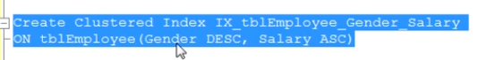



When we created a primary key it automatically adds a clustered index if there does not exists already, Now if we try to add a clustered index on salary and gender. It says there cannot be be more than one clustered index as there is already one on primary key so now we will have to drop primary key clustered index first.

When we tried to drop the clustered index from primary key

It gave error

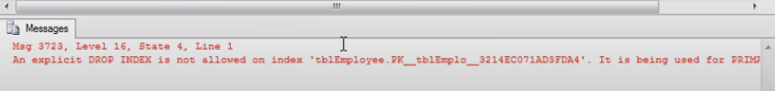

We can delete from here

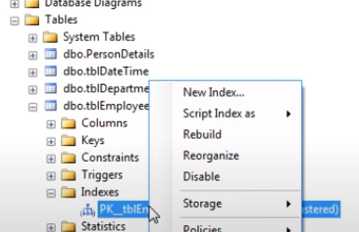

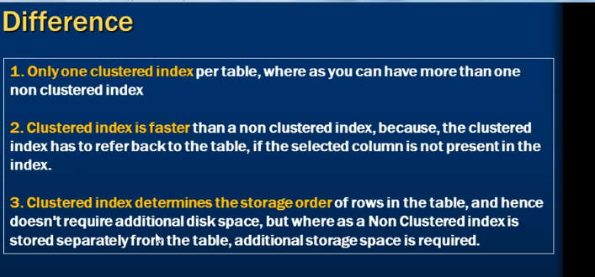

**Coding Questions**

1. 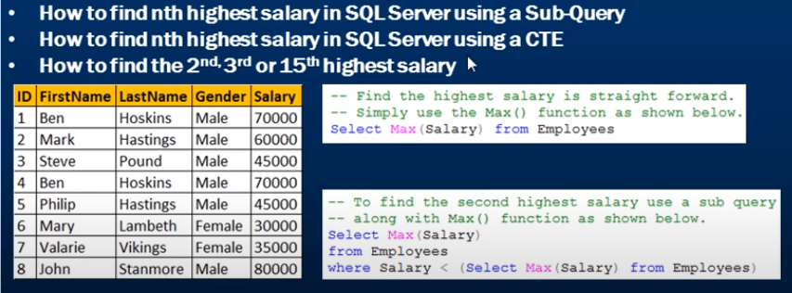

Create table Employees

(

     ID int primary key identity,

     FirstName nvarchar(50),

     LastName nvarchar(50),

     Gender nvarchar(50),

     Salary int

)

GO

Insert into Employees values ('Ben', 'Hoskins', 'Male', 70000)

Insert into Employees values ('Mark', 'Hastings', 'Male', 60000)

Insert into Employees values ('Steve', 'Pound', 'Male', 45000)

Insert into Employees values ('Ben', 'Hoskins', 'Male', 70000)

Insert into Employees values ('Philip', 'Hastings', 'Male', 45000)

Insert into Employees values ('Mary', 'Lambeth', 'Female', 30000)

Insert into Employees values ('Valarie', 'Vikings', 'Female', 35000)

Insert into Employees values ('John', 'Stanmore', 'Male', 80000)

GO

Ans:

We can solve this using three queries:

* select max(salary) from employees where salary < (select max(salary) as salary

from employees)

* 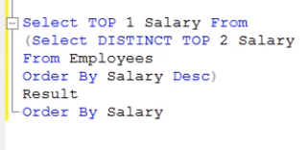
* 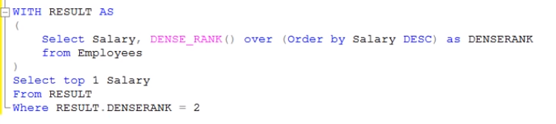

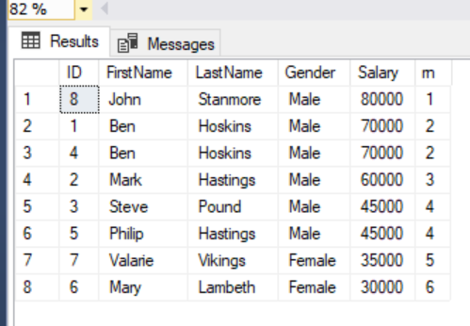

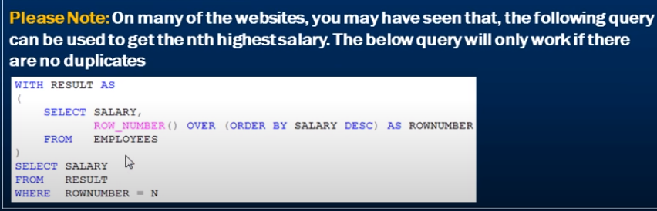

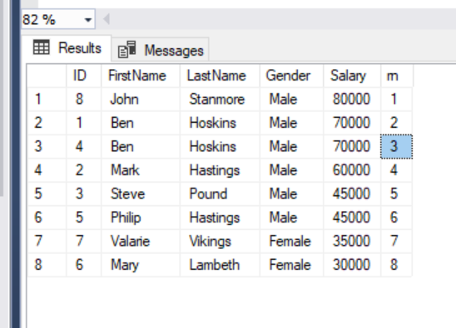

Create table Employees (

ID int,

FirstName nvarchar(50),

LastName nvarchar(50),

Gender nvarchar(50),

Salary int

)

GO

Insert into Employees values (1, 'Mark', 'Hastings', 'Male', 60000)

Insert into Employees values (1, 'Mark', 'Hastings', 'Male', 60000)

Insert into Employees values (1, 'Mark', 'Hastings', 'Male', 60000)

Insert into Employees values (2, 'Mary', 'Lambeth', 'Female', 30000)

Insert into Employees values (2, 'Mary', 'Lambeth', 'Female', 30000)

Insert into Employees values (3, 'Ben', 'Hoskins', 'Male', 70000)

Insert into Employees values (3, 'Ben', 'Hoskins', 'Male', 70000)

Insert into Employees values (3, 'Ben', 'Hoskins', 'Male', 70000)

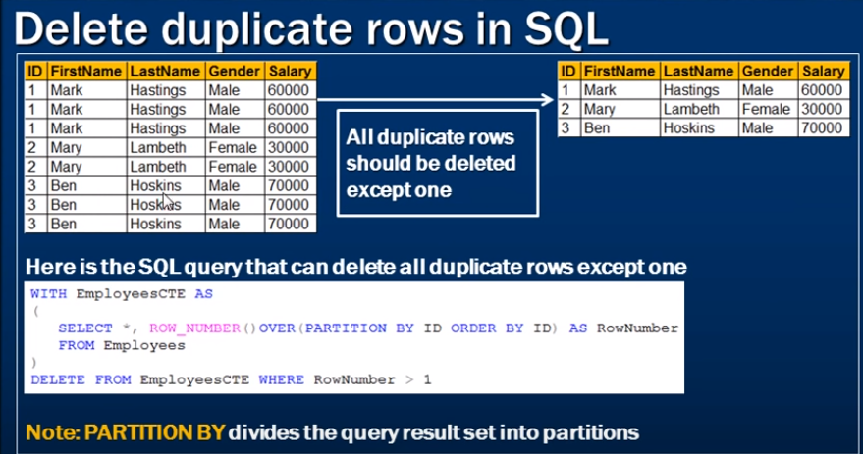

with resultcte as

(

select * , ROW_NUMBER() over (partition by id order by id) as rn from employees1

)

delete from resultcte where resultcte.rn >1

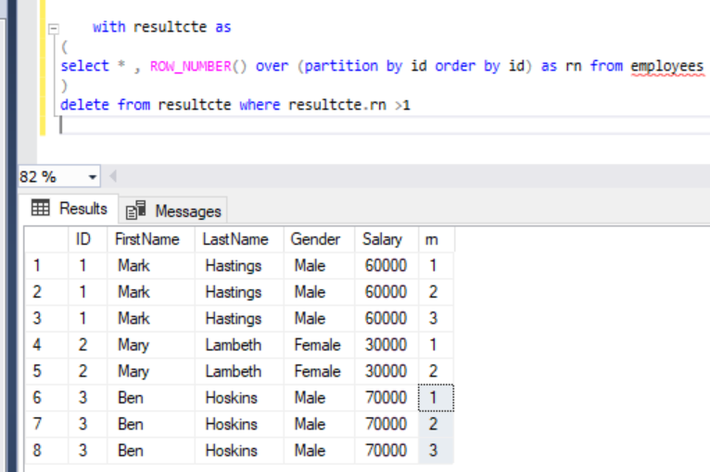

1. 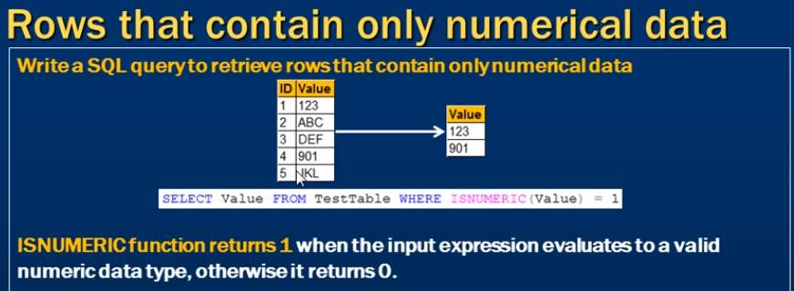

Create Table TestTable ( ID int identity primary key, Value nvarchar(50) )

Insert into TestTable values ('123'); Insert into TestTable values ('ABC'); Insert into TestTable values ('DEF'); Insert into TestTable values ('901'); Insert into TestTable values ('JKL')

select * from testtable where ISNUMERIC(value)=1

1. 

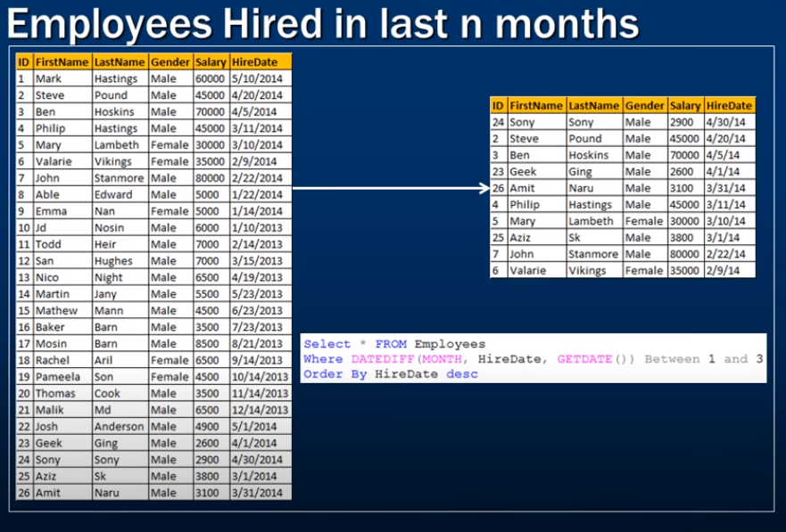

Create table Employees

(

     ID int primary key identity,

     FirstName nvarchar(50),

     LastName nvarchar(50),

     Gender nvarchar(50),

     Salary int,

     HireDate DateTime

)

GO

Insert into Employees values('Mark','Hastings','Male',60000,'5/10/2014')

Insert into Employees values('Steve','Pound','Male',45000,'4/20/2014')

Insert into Employees values('Ben','Hoskins','Male',70000,'4/5/2014')

Insert into Employees values('Philip','Hastings','Male',45000,'3/11/2014')

Insert into Employees values('Mary','Lambeth','Female',30000,'3/10/2014')

Insert into Employees values('Valarie','Vikings','Female',35000,'2/9/2014')

Insert into Employees values('John','Stanmore','Male',80000,'2/22/2014')

Insert into Employees values('Able','Edward','Male',5000,'1/22/2014')

Insert into Employees values('Emma','Nan','Female',5000,'1/14/2014')

Insert into Employees values('Jd','Nosin','Male',6000,'1/10/2013')

Insert into Employees values('Todd','Heir','Male',7000,'2/14/2013')

Insert into Employees values('San','Hughes','Male',7000,'3/15/2013')

Insert into Employees values('Nico','Night','Male',6500,'4/19/2013')

Insert into Employees values('Martin','Jany','Male',5500,'5/23/2013')

Insert into Employees values('Mathew','Mann','Male',4500,'6/23/2013')

Insert into Employees values('Baker','Barn','Male',3500,'7/23/2013')

Insert into Employees values('Mosin','Barn','Male',8500,'8/21/2013')

Insert into Employees values('Rachel','Aril','Female',6500,'9/14/2013')

Insert into Employees values('Pameela','Son','Female',4500,'10/14/2013')

Insert into Employees values('Thomas','Cook','Male',3500,'11/14/2013')

Insert into Employees values('Malik','Md','Male',6500,'12/14/2013')

Insert into Employees values('Josh','Anderson','Male',4900,'5/1/2014')

Insert into Employees values('Geek','Ging','Male',2600,'4/1/2014')

Insert into Employees values('Sony','Sony','Male',2900,'4/30/2014')

Insert into Employees values('Aziz','Sk','Male',3800,'3/1/2014')

Insert into Employees values('Amit','Naru','Male',3100,'3/31/2014')

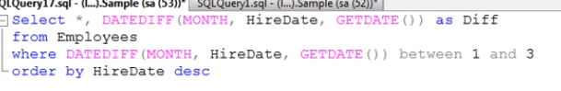

1. 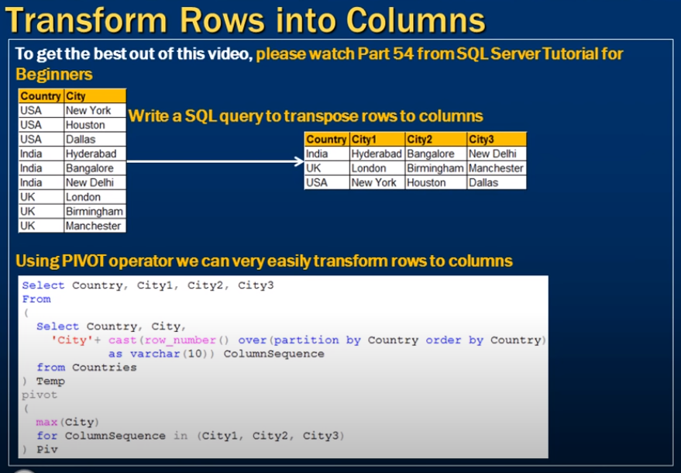

Create Table Countries ( Country nvarchar(50), City nvarchar(50) ) GO

Insert into Countries values ('USA','New York')

Insert into Countries values ('USA','Houston')

Insert into Countries values ('USA','Dallas')

Insert into Countries values ('India','Hyderabad')

Insert into Countries values ('India','Bangalore')

Insert into Countries values ('India','New Delhi')

Insert into Countries values ('UK','London')

Insert into Countries values ('UK','Birmingham')

Insert into Countries values ('UK','Manchester')

select country,city1,city2,city3 from

(

select *, 'city' + cast(ROW_NUMBER() over (partition by country order by country) as varchar(100)) as rn from countries

)

result

pivot

(

max(city)

for rn in (city1,city2,city3)

)

Piv

Note: Had there been for city for one of the country then add city4 in select and for statement.

1. 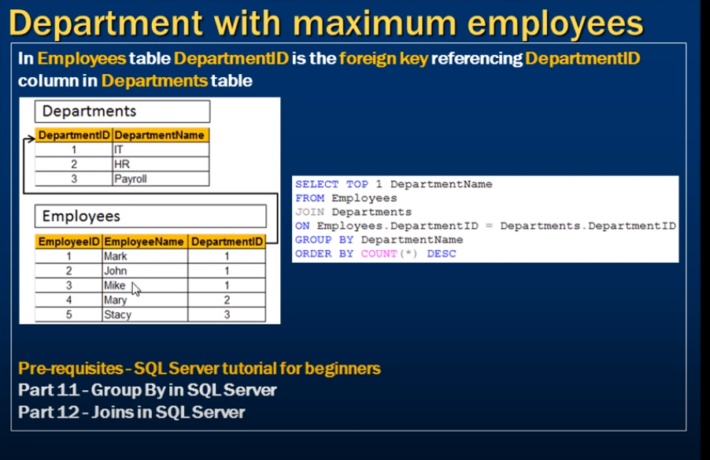

Create Table Departments

(

     DepartmentID int primary key,

     DepartmentName nvarchar(50)

)

GO

Create Table Employees

(

     EmployeeID int primary key,

     EmployeeName nvarchar(50),

     DepartmentID int foreign key references Departments(DepartmentID)

)

GO

Insert into Departments values (1, 'IT')

Insert into Departments values (2, 'HR')

Insert into Departments values (3, 'Payroll')

GO

Insert into Employees values (1, 'Mark', 1)

Insert into Employees values (2, 'John', 1)

Insert into Employees values (3, 'Mike', 1)

Insert into Employees values (4, 'Mary', 2)

Insert into Employees values (5, 'Stacy', 3)

GO

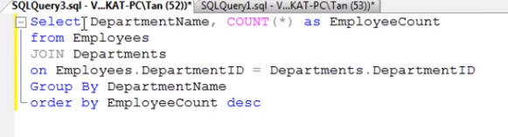

Or

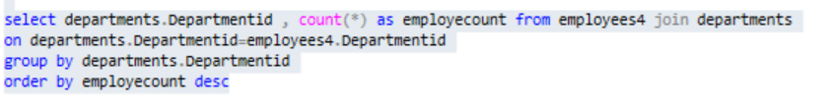

1. 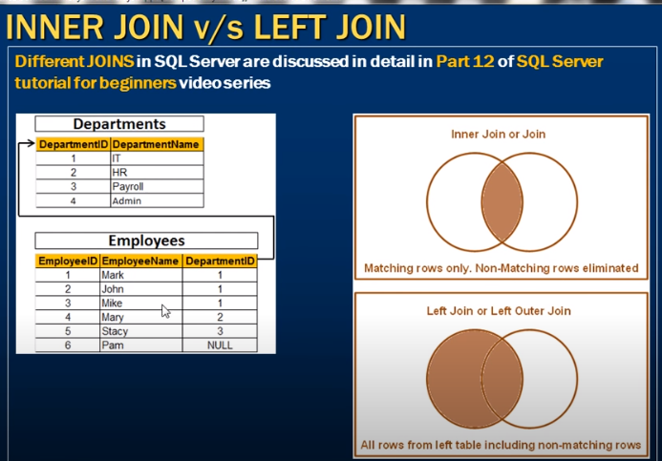

Create Table Departments

(

     DepartmentID int primary key,

     DepartmentName nvarchar(50)

)

GO

Create Table Employees

(

     EmployeeID int primary key,

     EmployeeName nvarchar(50),

     DepartmentID int foreign key references Departments(DepartmentID)

)

GO

Insert into Departments values (1, 'IT')

Insert into Departments values (2, 'HR')

Insert into Departments values (3, 'Payroll')

Insert into Departments values (4, 'Admin')

GO

Insert into Employees values (1, 'Mark', 1)

Insert into Employees values (2, 'John', 1)

Insert into Employees values (3, 'Mike', 1)

Insert into Employees values (4, 'Mary', 2)

Insert into Employees values (5, 'Stacy', 3)

Insert into Employees values (6, 'Pam', NULL)

GO

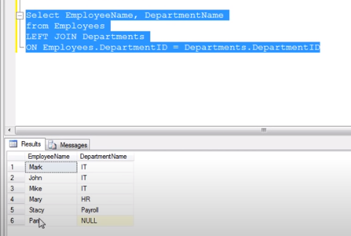

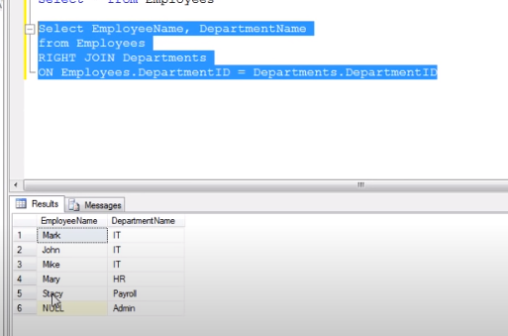

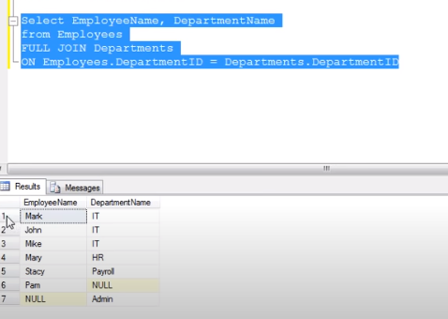

1. 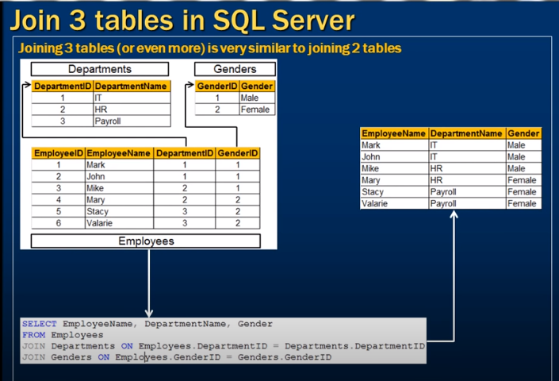

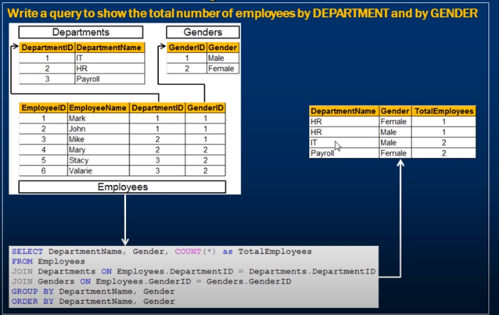

Create Table Departments

(

     DepartmentID int primary key,

     DepartmentName nvarchar(50)

)

GO

Create Table Genders

(

     GenderID int primary key,

     Gender nvarchar(50)

)

GO

Create Table Employees

(

     EmployeeID int primary key,

     EmployeeName nvarchar(50),

     DepartmentID int foreign key references Departments(DepartmentID),

     GenderID int foreign key references Genders(GenderID)

)

GO

Insert into Departments values (1, 'IT')

Insert into Departments values (2, 'HR')

Insert into Departments values (3, 'Payroll')

GO

Insert into Genders values (1, 'Male')

Insert into Genders values (2, 'Female')

GO

Insert into Employees values (1, 'Mark', 1, 1)

Insert into Employees values (2, 'John', 1, 1)

Insert into Employees values (3, 'Mike', 2, 1)

Insert into Employees values (4, 'Mary', 2, 2)

Insert into Employees values (5, 'Stacy', 3, 2)

Insert into Employees values (6, 'Valarie', 3, 2)

GO

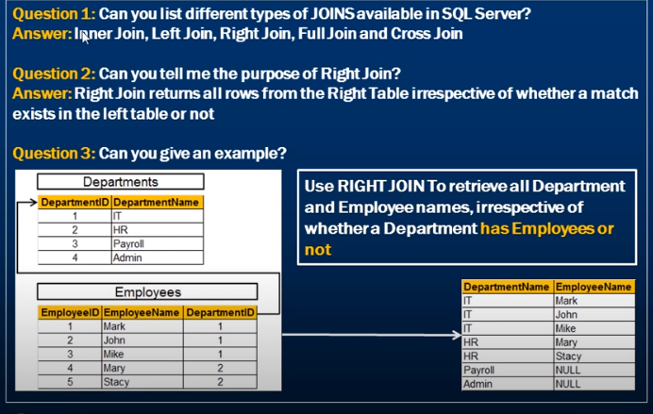

Create Table Departments

(

     DepartmentID int primary key,

     DepartmentName nvarchar(50)

)

GO

Create Table Employees

(

     EmployeeID int primary key,

     EmployeeName nvarchar(50),

     DepartmentID int foreign key references Departments(DepartmentID)

)

GO

Insert into Departments values (1, 'IT')

Insert into Departments values (2, 'HR')

Insert into Departments values (3, 'Payroll')

Insert into Departments values (4, 'Admin')

GO

Insert into Employees values (1, 'Mark', 1)

Insert into Employees values (2, 'John', 1)

Insert into Employees values (3, 'Mike', 1)

Insert into Employees values (4, 'Mary', 2)

Insert into Employees values (5, 'Stacy', 2)

GO

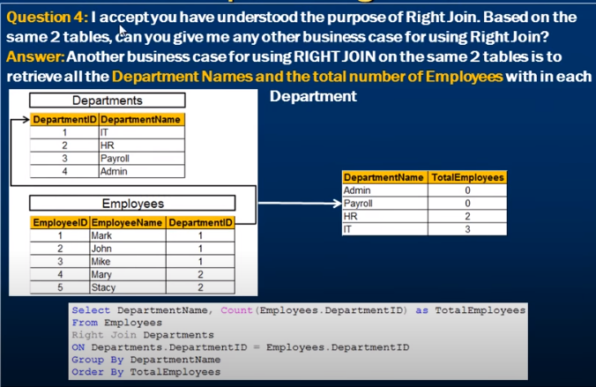

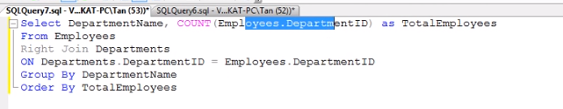

Below is wrong as we have used count(*) so it is giving one record for department table.

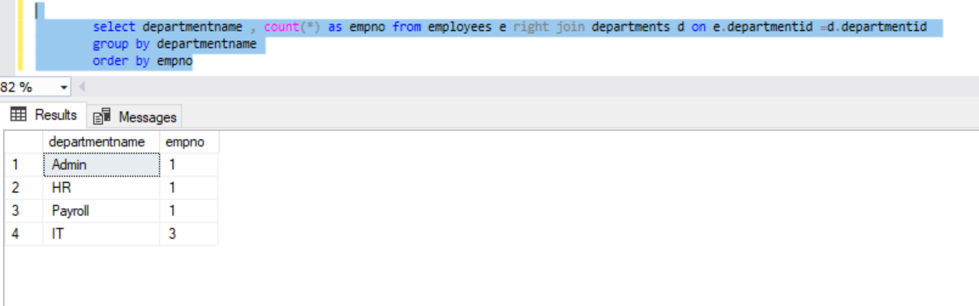

1. 

Create table Students

(

     ID int primary key identity,

     Name nvarchar(50),

     Gender nvarchar(50),

     Salary int

)

Go

Insert into Students values ('Mark', 'Male', 60000)

Insert into Students values ('Steve', 'Male', 45000)

Insert into Students values ('James', 'Male', 70000)

Insert into Students values ('Mike', 'Male', 45000)

Insert into Students values ('Mary', 'Female', 30000)

Insert into Students values ('Valarie', 'Female', 35000)

Insert into Students values ('John', 'Male', 80000)

Go

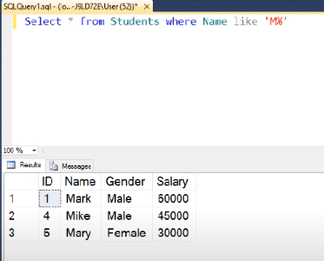

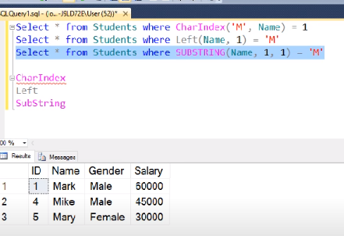

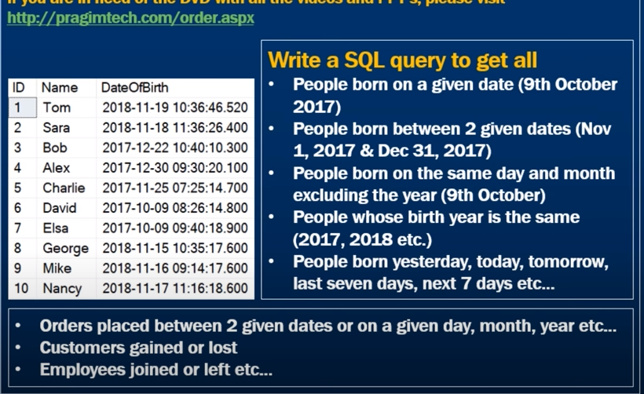

Create Table Employees

(

       ID int identity primary key,

       Name nvarchar(50),

       DateOfBirth DateTime

)

Insert Into Employees Values ('Tom', '2018-11-19 10:36:46.520')

Insert Into Employees Values ('Sara', '2018-11-18 11:36:26.400')

Insert Into Employees Values ('Bob', '2017-12-22 10:40:10.300')

Insert Into Employees Values ('Alex', '2017-12-30 9:30:20.100')

Insert Into Employees Values ('Charlie', '2017-11-25 7:25:14.700')

Insert Into Employees Values ('David', '2017-10-09 8:26:14.800')

Insert Into Employees Values ('Elsa', '2017-10-09 9:40:18.900')

Insert Into Employees Values ('George', '2018-11-15 10:35:17.600')

Insert Into Employees Values ('Mike', '2018-11-16 9:14:17.600')

Insert Into Employees Values ('Nancy', '2018-11-17 11:16:18.600')

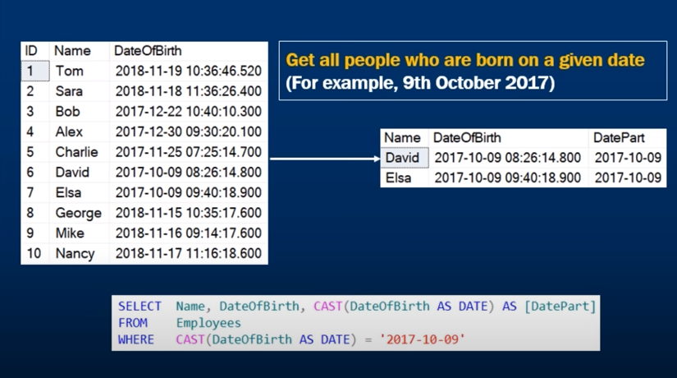

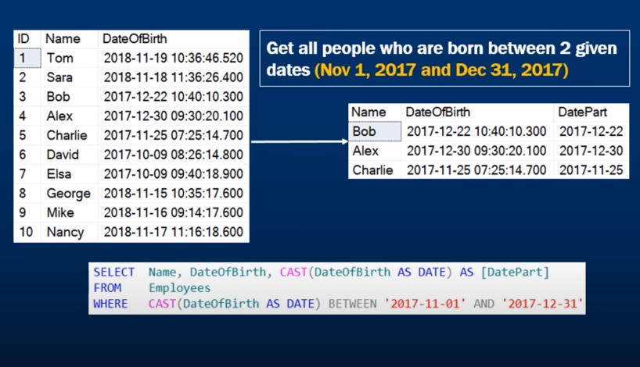

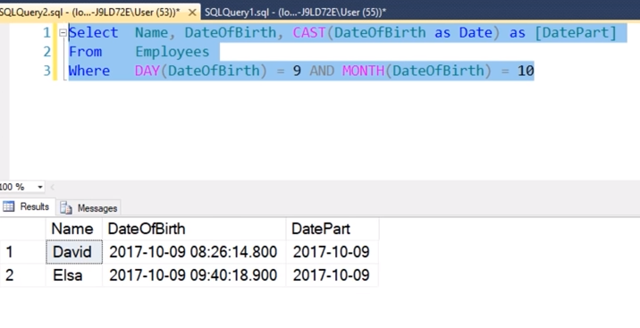

year

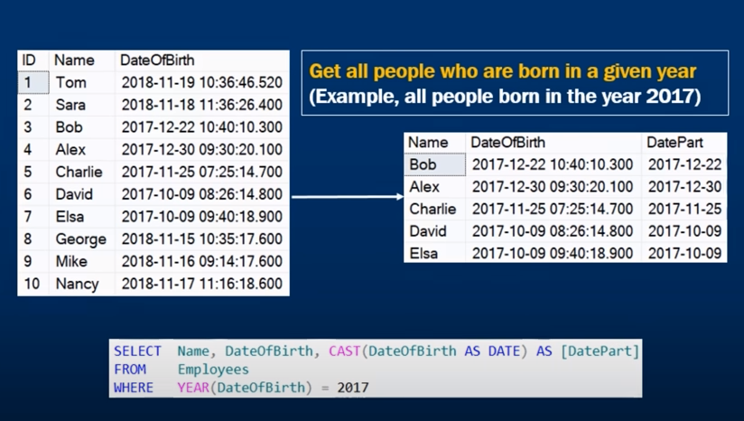

Yesterday

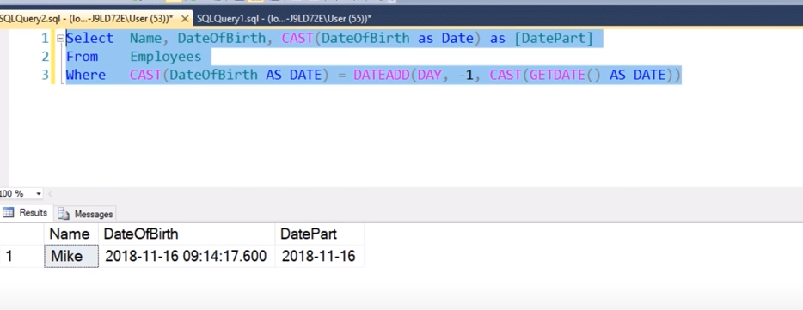

**Tomorrow**

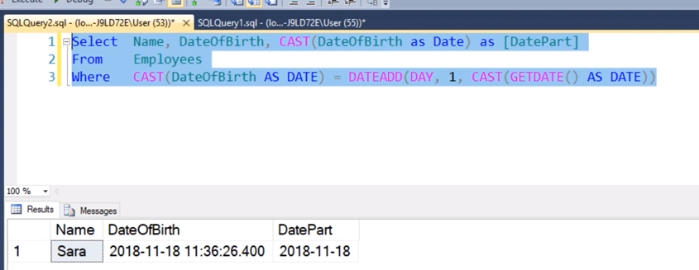

All people since yeaterday. -> This means yesterday and today.

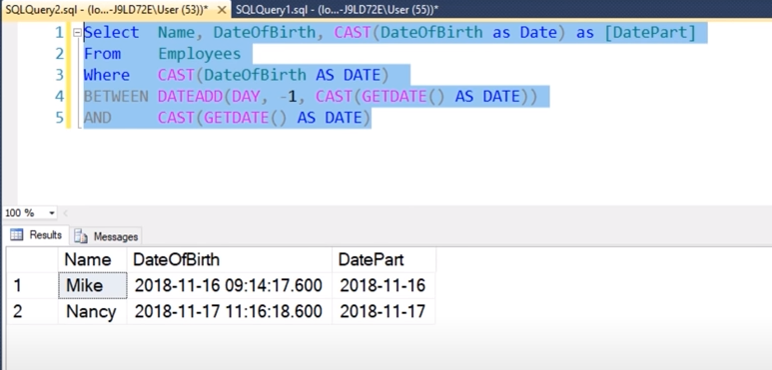

In last seven days from today -> this means excluding today.

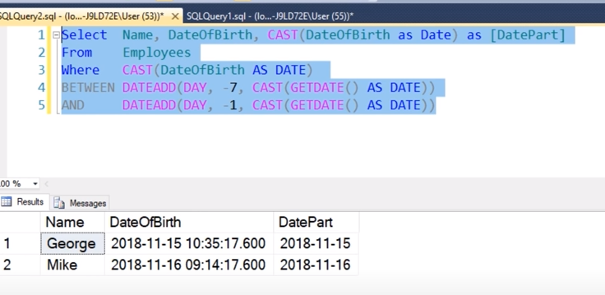

1. 

yes, but it has to be of same data type other wise it gives error. Int and decimal works though but typecasting happens there. Int and text will give error.

Create table Departments

(

     ID int not null,

     Name nvarchar(50),

     Location nvarchar(50)

)

GO

Create table Employees

(

     ID int,

     Name nvarchar(50),

     Gender nvarchar(50),

     Salary int,

     DepartmentId int

)

GO

Insert into Departments values (1, 'IT', 'New York')

Insert into Departments values (2, 'HR', 'London')

Insert into Departments values (3, 'Payroll', 'Sydney')

GO

Insert into Employees values (1, 'Mark', 'Male', 60000, 1)

Insert into Employees values (2, 'Steve', 'Male', 45000, 3)

Insert into Employees values (3, 'Ben', 'Male', 70000, 1)

Insert into Employees values (4, 'Philip', 'Male', 45000, 2)

Insert into Employees values (5, 'Mary', 'Female', 30000, 2)

Insert into Employees values (6, 'Valarie', 'Female', 35000, 3)

Insert into Employees values (7, 'John', 'Male', 80000, 1)

GO

--Other SQL Queries used in the demo

Create Table T1

(

     ID int,

     T1Column1 nvarchar(20)

)

GO

Insert into T1 values (1, 'T1 Value 1')

Insert into T1 values (2, 'T1 Value 2')

GO

Create Table T2

(

     ID decimal,

     T2Column1 nvarchar(20)

)

GO

Insert into T2 values (1, 'T2 Value 1')

Insert into T2 values (2, 'T2 Value 2')

GO

Select T1.T1Column1, T2.T2Column1

from T1

join T2 on T1.ID = T2.ID

Alter Table T2 Alter Column ID nvarchar(3)

Insert into T2 values('XX', 'T2 Value 3')

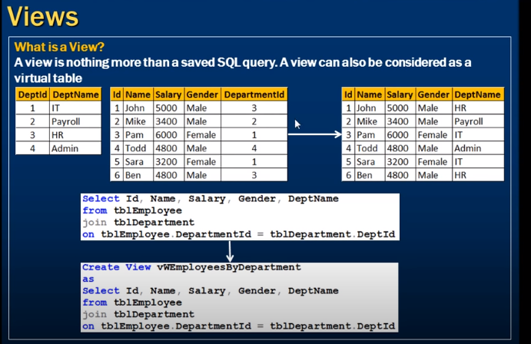

View is just as saved select query it is a virtual table.

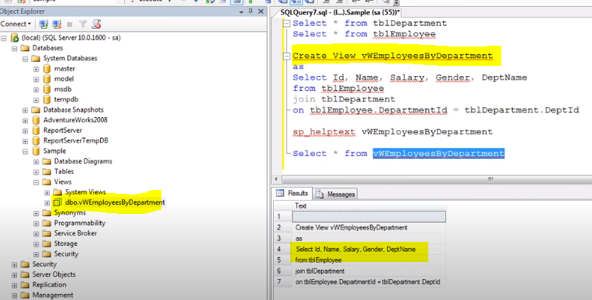

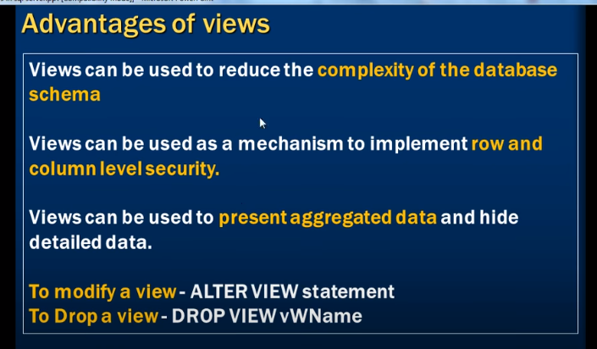

* Let say we have non it user so writing a query to join 5-6 tables is not simple in that case we can write a view and give access to the view to user and it is easy for then to look into view and mention were clause and look their data.
* There is IT department manager and we want to provide the access to only the IT employees of his department we can achieve that by creating a view which select only the IT employees and rest of the columns are not returned. So column row level security.below ex with query gives row level security

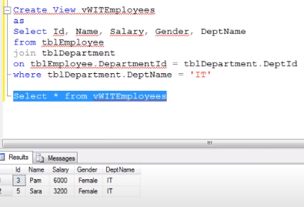

* Column level security do not fetch the salary column in select statement while creating views.

1. 

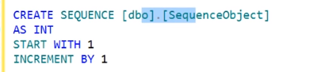

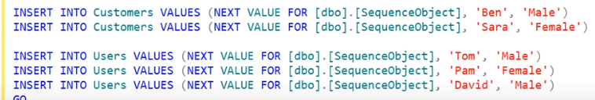

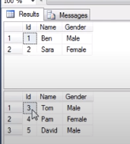

Identity is on column of a table and it’s value increases by each record in that table.

Sequence is on database level and it can be used on different tables as shown in pic 3

2. For identiy we need to insert a row for Sequence we donlt need to insert a row we can simply select the next value.

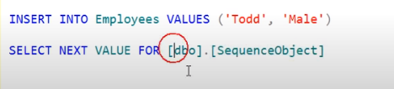

3. no max value for identity but for sequence

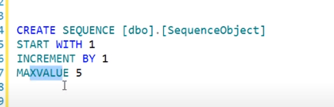

4. 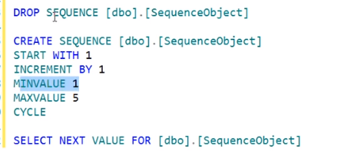

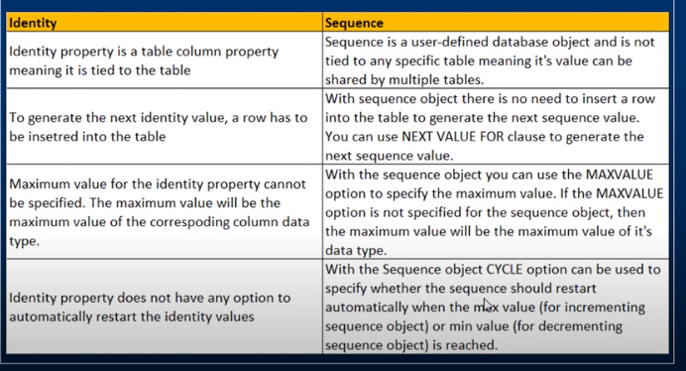

1. Where and Having

Having is on grouped data

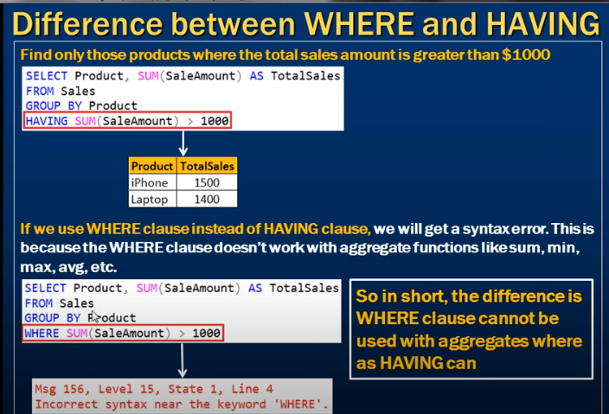

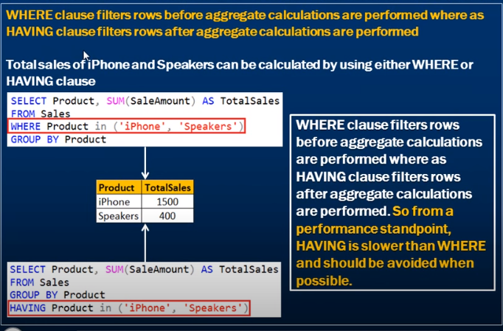

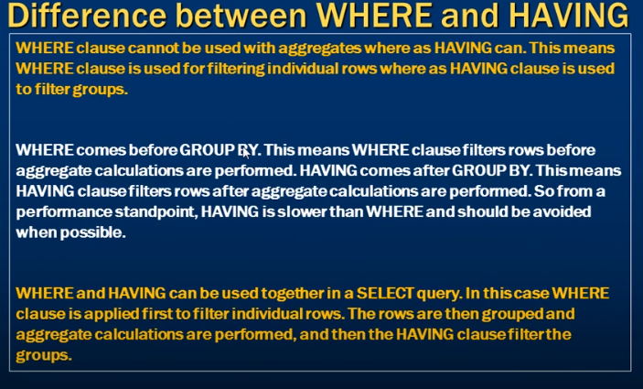

1. 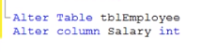To change the datatype of existing column.

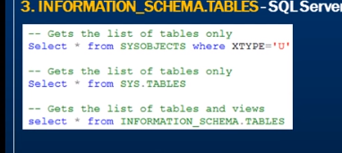

1. 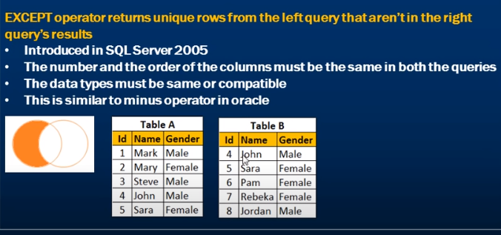

Create Table TableA

(

Id int primary key,

Name nvarchar(50),

Gender nvarchar(10)

)

Go

Insert into TableA values (1, 'Mark', 'Male')

Insert into TableA values (2, 'Mary', 'Female')

Insert into TableA values (3, 'Steve', 'Male')

Insert into TableA values (4, 'John', 'Male')

Insert into TableA values (5, 'Sara', 'Female')

Go

Create Table TableB

(

Id int primary key,

Name nvarchar(50),

Gender nvarchar(10)

)

Go

Insert into TableB values (4, 'John', 'Male')

Insert into TableB values (5, 'Sara', 'Female')

Insert into TableB values (6, 'Pam', 'Female')

Insert into TableB values (7, 'Rebeka', 'Female')

Insert into TableB values (8, 'Jordan', 'Male')

Go

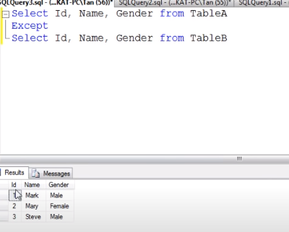

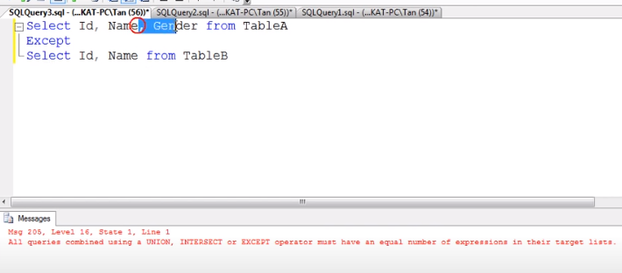

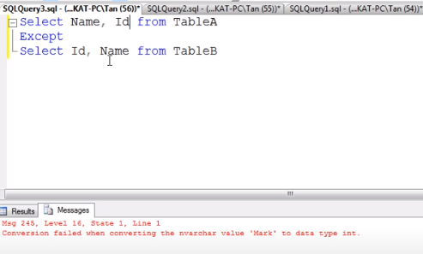

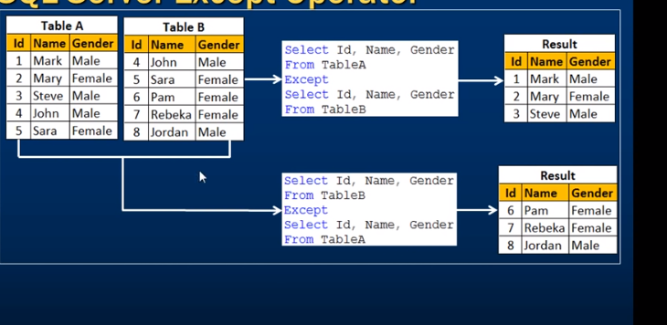

We can use it on single table and we can even have where clause.so we get whose salarys are between 50k and 60k.

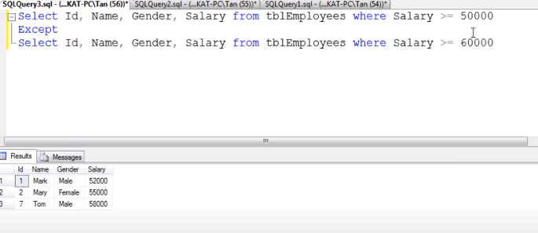

1. 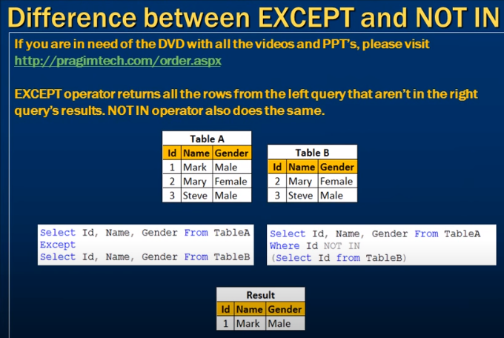

Therefore, Not in, Except and Minus does the same thing.



1. 